## Team Profile

#### Summary

The Red Panthers team is dominantly analytical types who are endowed with intellectual gifts, but lacking the innate skills for keeping a team glued together. However, we have a couple of characters with natural gifts in leadership and communication. These fill the void and present a real opportunity for a group of individuals to come together and achieve goals.

The functional quirkiness of this group shows through in all the tests the group has undertaken but best illustrated by a comparison of the Myers Briggs results. The discussion below focuses on the Myers Briggs, as any insight from the other tests is hard to articulate (mostly because they are all different tests) and doesn’t offer any greater insight than the Myers Briggs alone.

The table below illustrates the tests undertaken by the Red Panthers

##### TABLE: Red Panthers Personality Tests

|  |  |  |  |
| --- | --- | --- | --- |
| **Member** | **Myers-Briggs (type and type description)** | **Test 2 (test Name and result)** | **Learning style** |
| Anthony Brown | INTP | DISC profile | Tactile Learner |
|  | Logician | Factfinder |  |
|  |  |  |  |
| Tim Damon | INFP-T | Big five personality test | Auditory Learner |
|  | Mediator | too difficult to summarise in a table |  |
|  |  |  |  |
| Shaun Lottey | ENFJ-A | Creativity Test | Auditory Learner |
|  | Protagonist | creativity level is: High |  |
|  |  |  |  |
| Jake McAndrew | INTJ | Big five personality test | Auditory/Visual Learner |
|  | Architect | too difficult to summarise in a table |  |
|  |  |  |  |
| Jason Tilgner | INTJ | Colour test | Visual Learner |
|  | Architect | too difficult to summarise in a table |  |
|  |  |  |  |
| Jason Walstab | ENTP-T | Creativity Test | Visual Learner |
|  | Debater | creativity level is: High |  |

Name: Anthony Brown

Student Number: s3460996

Hometown: Caloundra, Australia

Education: University of Queensland, BA applied Science

Current Job: Home dad

Quick Bio:

My name is Anthony. I am one of the Red Panthers.

My interest in IT started when I was doing data analysis for my work with Parks and Wildlife. I found solutions to both research questions and business administration were best provided by IT knowledge. I have pursued my career and continued to find IT as the solution to the problem my managers asked me to solve. Over time, almost as if by accident, I have collected a gaggle of hardly related IT skills and knowledge. Study at RMIT is a way for me to bring these together and – hopefully – raise myself up to a better level.

Name: Jason Tilgner

Student Number: S3830312

Hometown: Yallourn North, Vic

Education: Certificate IV in information technology

Current Job: IT Support Officer / Desktop Support

Quick Bio: My Name is Jason, and I am in a team with the red panthers. I live just outside of a country town called Yallourn North with my family and cat called tyrion. I have been working in a few different IT positions over the last 10 years, and have also got a couple of different IT certificates. I am doing this course as I enjoy IT and also wish to progress my current career into software development or project management. My main hobby is I like to gym.

I have been working on a couple different IT service desks over the last few years, this includes application support and also general generic support. When I am not working in IT in my professional life, I also enjoy gaming and playing with people from all over the world in different MMO’s.

Name: Jake McAndrew

Student number: s**3818850**

Hometown: Sydney

Education: Year 12

Current Job: Store man at Kmart

IT Skills/interest: Java, Cyber security

My name is Jake McAndrew, I’m 22 years old and have lived in Sydney all my life, but plan to someday move to Melbourne to explore new opportunities. I currently live at home with my parents and my twin brother who has very different interests to me and is pursuing a career in the military. I also have a sister who lives in Queensland who is a recently graduated medical doctor. I was born in Australia, but my family originally comes from Ireland and Scotland. Currently I can only speak English, but I would love to one day learn a new language, possibly Gaelic. Recently I started coding in java and loved it so much that I decided to make it my career, I now spend most of my free time coding to hone my skills. I have always been very passionate about all aspects of IT/Computer Science, but I’ve always had a particular interest in cyber security. I plan to use this degree as a launching pad into a computer science degree specializing in cyber security in the not too distant future. I like to spend most of my free time playing video games, coding in java, building computers, making music and lifting weights. I am currently a full-time employee at Kmart and have been for a number of years. I hope one day to leave my current job and obtain my dream career working as a cyber security expert.

Name: Jason Walstab

Student Number: s3291269

Hometown: Central Coast, Australia

Education: TAFE NSW Certificate IV in Networking

Current Job: Small business owner ([www.quantumdata.com.au](http://www.quantumdata.com.au/))

Quick Bio:

My name is Jason but I usually go by Jay, and I am on the Red Panthers team. I live in the “small”, quiet city of NanJing (population around 11.5 million) in China, with my wife and son and have done for the last decade or so.

I have always had a great interest in IT, and I have been working in the industry since I was 18. I started off in helpdesk, moved to sys admin and then on to work on CT machines (Philips Brightview XCT systems) and finally started my own IoT company here in China. I have made IT my life and will continue to follow that path, hoping this degree will help along the way.

I have worked with many different IT technologies, but now I mainly focus on NodeJS, ESP-32 micro-controllers and Linux cloud server management. I hope to one day return to Australia and get a full-time job in programming one day so I can spend more time with my family.

I have many hobbies which are electronics, programming, surfing, motor bikes the gym and recently have been getting into digital art as well as game design. I have spent many years learning language and now speak mandarin Chinese at a fluent (enough) level, maybe at the expense of my English though...! I spend most of my free-time spending time with my son and wife and going out with friends and have a comfortable but busy life here.

Name: Shaun Lottey

Student Number: S3829826

Hometown: Sydney, Australia

Education: Trinity Catholic College, Class of 2007

Current Job: Driver/Storeperson

Quick Bio:

My name is Shaun and I am one of the Red Panthers. I have had an interest in IT since a very young age. While I hold no formal qualifications nor have, I ever worked in the industry sector I have been tinkering with hardware and software since I was 5, starting with an (ancient by todays comparisons) Commodore 64.

In primary and high school, my friends and I would enjoy collecting second hand hardware components such as used server racks or PCs that our school had scheduled to be decommissioned and rebuilding them to our purposes.

From the ages of about 10 onwards, I began to experiment with programming using utilities such as RPGMaker or making custom mods for popular FPS titles such as Half-Life. I also learned a lot back then about HTML, PHP & SQL using it to develop and maintain online forums.

I also play guitar and enjoy playing online games with my friends, who are from all over the world.

Name: Tim Damon

Student Number: S3829497

Home Town: Wonthaggi, Vic

Education: Year 12 (2013), Cert III in Retail and Hospitality (5 units of each), Test and Tag Cert.

Bio: I Developed an interest in IT at a young age through video games and expanded my interest through using various types of computers and discovering what they can do.

Recently was able to build my first PC after being interested in doing it for so long, this sparked a further interest in the more "behind-the-scenes" workings of IT.

My IT experience is limited mostly to fixing minor issues for family and friends, but also includes imaging 1000+ laptops with Windows for a local high school so that they could be used by the students.

My hobbies mostly include playing (and collecting) Video Games with my friends, browsing the internet (watching videos or reading interesting articles) and watching movies and TV shows.

# Group Processes

The group after the assignment two feedback while we had some constructive feedback, has not changed the way the method of how we are organising the project. We are still using our online tools to meet up and following the methods of our previous approach. So despite the pressure our group was under to meet there deadlines and also deal with normal every day life we managed to get our deadlines done.

## Comparing Career Plans

Jason Walstab would like to pursue a career as an IoT Solutions Leader. He is undaunted by the esoteric nature of his career preference. His background gives him insight into the sector, and he feels there is a big future for IoT technology, and he wants to be a part of it.

No-one else in the Red Panthers wants to work with IoT. But, like Jason, the jobs data has not changed any of our career ambitions. What we all realised is that our ambitions are aspirations. Something each of use was working towards. We agreed that we will have to work our way towards these aspirations. It will not happen in a single step. We all see ourselves at the bottom of a mountain. WE are aiming for different peaks, but we might share similar roles along the path to our aspirational goal.

Anthony and Jason Tilgner both aim towards full stack developers. Both see a multitude, and varied, paths to this end. Both also agree that whatever path you take, communication skills: writing and interpersonal are important.

Tim and Shaun are committed to becoming game developers. Both are realistic to the difficulties in this field but are pragmatic about it. They will pursue a general coding profession with the hope that they can transition into this field later in their careers. Or, develop this interest as a side- hassle.

Jake wants to pursue a career in cybersecurity. This is hiss passion. He is discouraged by the low number of jobs in the area, but he, like Jason Walstab, see a future that is big, and which he wants to be a part. Jake’s endpoint is focused, but like the rest of use. He will pursue a general coding career while looking for openings in his preferred field.

WE see IT professional work can be divided into two parts. Technical skills, and the general getting-things-done-skills. Wherever you might work, you are developing talents in the later, and specialised skills in the former. In order to progress towards our specific roles, we may have to study on the side to develop the required skills, if our current role does not. But, any role in IT will build the getting-things-done-skills. You just need to be in a job to get these. And, you take them with you wherever you might go.

# The English as a Second Language flashcard system

## Download Links for submission build:

<https://github.com/ittgroup14/assignment2/blob/master/assignment3/FlashcardSystemv0.03.zip>

# Project Overview

## Topic

The project is to create a flashcard system for teaching basic English nouns to children whose primary language is not English.

A flashcard is a combination of an image of an object with its name and a sound file demonstrating how the word is pronounced. The software will teach basic English nouns to children using a flashcard system. It will have mini games to keep the children interested and engaged through the process. Users will be able to customise the app by adding their own flashcards. The customisation will empower the end-user to improve the app for use in ways that fit their ESL curriculum.

We intend on building a small, focused application that provides a simple tool to help with this specific part of language acquisition. The product will be available as a standalone website and on app stores. We also hope to make the software offline functional to enable use by remote communities who don’t have high-end technology or qualified teachers to teach English.

## Motivation

People worldwide consider English to be the most valuable language to learn as a second language (Taylor, 2020). Research has predicted that the market for learning English as a second language (ESL) will grow 7.1% and is expecting to hit the $54.8 billion mark by 2025 (Research, 2020). Our motivation is to tap into this growing market and help children learn some English in areas of the world that do not have access to native English speakers to teach them. Vietnam, for example, where there is a documented lack of English teachers available to meet the demand (News 2020).

Completing this project would show that our team was able to work together to produce a viable product. It would demonstrate that we could identify a need and craft a solution that fits within it. We consider success to be a high adoption rate. If successful, our project will an example of us using our skills to help the global community.

## Landscape

There are many existing applications in the market for teaching children second languages, especially English, as it is the most popular second language. A popular ESL flashcard system aimed at ESL kids is called Lingo Kids ([www.lingokids.com](http://www.lingokids.com/)). We see three significant differences between our application and Lingo Kids, being:

1. ours can be customised, by adding new flashcard decks
2. We will allow people to share their customisations
3. We will also provide our application one hundred per cent free

Many of the competitors in this market seek to generate income from selling in-app advertising. In adopting this strategy, our competitors inherently geared towards more affluent urban areas that can access the items advertised.

For our motivations, market penetration (numbers uptake) is more important than profitability – our motive is to demonstrate our IT skills. We hope our strategy of not charging, or including advertising, will make the application more favourable for kids in rural, less wealthy areas. Because of this, we are open ourselves to a significant market segment that other competitors don’t value highly.

# Aims and Goals

## Project Aim

#### 1.0 Build an English as a Second Language flashcard system.

We aim to develop a basic working ESL flashcard application that can:

1. dynamically load flashcards
2. Initiate a the basic operation of cycling through the flashcards

### Enhancement Aims

#### 1.1. Add mini-game – choose the correct card

The mini-game will make learning with the flashcards more engaging of children.

#### 1.2. Add mini-game – memory game

The mini-game will make learning with the flashcards more engaging of children.

#### 1.3. Add flashcard customisation

The customisation will allow users to add new flashcards by combining a word with an image. The user will then be able to store their new cards in custom decks.

#### 1.4. Add customisation sharing options

Users will be able to store custom decks on the cloud. The community of users may search and download any custom decks where the owner has made them to publicly accessible. We envision forceful censorship to ensure the appropriateness of the content is maintained.

## Project management aims

#### 1.4. Create a presentation video

The video will outline what the project is and why it is worthwhile to build. Our marketing video will showcase our software to people who would be interested in it (I.e. schools, parents, teachers or education companies).

#### 1.5. Create a web site for the project

The web site will act as an access point for the project and expand as the project matures. The site will be an access point where people can download the software and extra flashcard sets. People may also view documentation or marketing material related to the product.

## Goals To achieve project aim 1.0

#### 1.0.1 Outline the core functionality of the application

List the core functions the application will provide.

#### 1.0.2 Draft a menu workflow

Decide how the app will flow between functions and draw up a menu structure that will enable this.

#### 1.0.3 Create a workable main menu and .exe package

This goal would be to create a working main menu prototype for our ESL flashcard software that will run on a Windows operating system from an executable file.

##### 1.0.3.1 tested menu functionality

##### 1.0.3.2 test user experience (UX) to ensure the GUI menu is clear and easy to navigate

##### 1.0.3.3 document menu

##### 1.0.3.4 add a background image

##### 1.0.3.5 add some background music.

#### 1.0.4 Create a basic set of twenty flashcards image files.

This goal would require us to source royalty-free images or create our own. The goal would be to have at least twenty of these to showcase the software. Match the images files to the English noun.

##### 1.0.5 Create a matching set of audio recordings for the images.

The goal here would be to have an audio recording for each flashcard image file we have (demonstrating the pronunciation). The audio recordings are to be brief, clearly spoken and match the English noun for the flashcard.

##### 1.0.4.1 test the audio files satisfy the criteria (outlined above)

##### 1.0.4.2 test images, audio and word (noun) match, and are comprehensible to the target audience

#### 1.0.6 Create a dynamic flashcard loading system.

The application will have a dynamic flashcard loading system that uses the files stored in the flashcards folder. The app will cycle through the folder files and compile them into flashcards. The flashcards will be grouped into decks and arranged within that deck in a defined order. No matter how many cards are in the folder, the software would need to be able to add them dynamically. This feature would also need to be tested for bugs and usability as well as having an easy to access

##### 1.0.6.1 document possible errors and how they will be handling

##### 1.0.6.1 test - the flashcards components are matched correctly

##### 1.0.6.2 test - that the app handles missing components in an appropriate way

##### 1.0.6.3 test - UX that the app reports missing components to the user clearly

##### 1.0.6.3 test – 0, 1 or 1000 flashcards do not cause app failure

#### 1.0.7 Create the game-play engine

Upon the selection of the appropriate menu item, The application starts the game mode. Once entered the game will run as documented. The app will exit the game-mode upon request and return to the home screen.

##### 1.0.7.1 write the engine

##### 1.0.6.1 test – the app initiates the game correctly

##### 1.0.7.2 app exit the game correctly

##### 1.0.6.2 the game runs as documented

##### 1.0.6.3 test - UX that the game fits the screen correctly and the target clients can operate the controls

## Goals To achieve project enhancements

#### 1.1.1 Create a working mini-game (Choose the correct card).

Our goal here would be to create a single mini game that is working and tested. The first mini game to create would be the ‘choose the correct card’ game. The specifications for this game are detailed later in this document.

##### 1.1.1.1 review specifications and write a list of achievable goals

##### 1.1.1.2 implement the goals

#### 1.2.1 Create a second working mini-game (Memory).

Our goal here would be to create a second mini game that is working and tested. The second mini game to create would be the ‘memory’ game. The specifications for this game are detailed later in this document.

##### 1.2.1.1 review specifications and write a list of achievable goals

##### 1.2.1.2 implement the goals

#### 1.3.1 Add flashcard customisation

The goal is to allow users to add new cards, and store them into decks

##### 1.3.1.1 develop a workflow for importing the required components from the client

##### 1.3.1.2 implement the workflow

##### 1.3.1.3 test the implementation

#### 1.4.1 Add customisation sharing options

The goal is to have a method where the clients can load their customisations to the cloud, where other clients can download and use the new flashcards.

##### 1.3.1.1 develop a security and appropriateness strategy

##### 1.3.1.2 develop a workflow for cloud storage

##### 1.3.1.3 implement the workflow

##### 1.3.1.3 test the implementation

Possible future functionality

-The addition of a language selection when opening the game so that the games menu’s will be displayed in a language the user knows rather than one they are learning, to make navigation easier for those learning English.

-The addition of a 2nd language selection option (possibly a menu option or a pop-up on game open) to select the language which the user wishes to learn, allowing this game to useful in learning multiple languages not just as a tool for ESL. Would require additional assets to be created for each language included.

-A score tracking system for each game so that users may be able to see how they are improving with learning English (or other language). Allow the user to enter their name and save their score at the end of each round, and display their recent or high scores afterwards. Could also create a menu option within the main menu to display previous scores without having to play the a game.

## Goals To achieve project management outcomes

#### 1.5.1 Create a presentation video

##### 1.5.1.1 generate video ideas and vote amongst the group

##### 1.5.1.2 expand the successful idea with storyboards and script outline

##### 1.5.1.3 shot the video

##### 1.5.1.4 edit the parts together

##### 

#### 1.6.1 Create a web site for the project

##### 1.6.1.1 generate a basic structure as a Github page

##### 1.6.1.2 plan future development

# Plans and Progress

## The Plan

### Planned features and flow of the software

The ESL flashcard system will start with these features, with the possibility to expand and add more features later as needed:

* The main menu
* A collection of stock flashcards (showing a picture and the English noun below it)
* A flashcard selection screen to choose the appropriate flashcards
* A system which allows users to add flashcards
* A ‘Click the correct card’ mini game
* A ‘Memory’ mini game

Planned Program Flow Diagram:

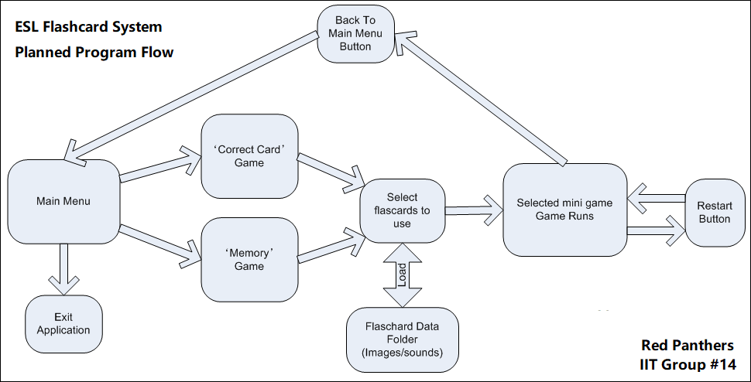

### The plan for the Main Menu.

The main menu will consist of three buttons:

* ‘Correct Card Game’
* ‘Memory Game’
* ‘Exit Application’

Clicking either of the game buttons will proceed to load up the selected mini-game, whereas the exit button will exit the application. The application will have an appropriate background image and a simple music loop.

### The plan for the Flashcards

The team will make a basic set of twenty flashcards to the following specifications:

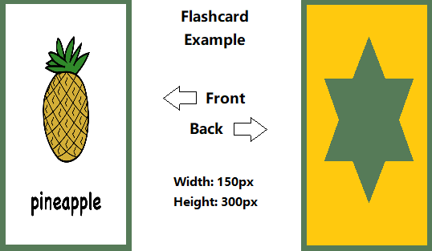

All flashcards will also have an accompanying audio file that reads the word on the flashcard in a .wav format.

### The plan for the ‘Flashcard Selection’ system

All flashcard image files, and audio files will be placed in a single folder in the applications root directory in an images folder, underneath a flashcards folder: (flashcards/images). Each flashcard image will be named based on the card in the .PNG image format, say for example ‘pineapple.png’. A corresponding audio file in the .WAV format will also be placed in an audio folder in that same flashcards directory (flashcards/audio) and will be named to match the image name (I.e. pineapple.wav).

The application will then dynamically load the image and audio files to create the flashcards in the applications flashcard selection page. The user will then have to select six flashcards. As the user clicks flashcards, they will turn green. Once the user has chosen six flashcards, they will continue to the mini game they had previously selected.

### The plan for the mini game ‘Click the correct card.’

A row of six flashcards will be displayed face up. The application pronounces one of the cards. The user then has 10 seconds to click on the matching flashcard. The user gets one point for a correct answer, or one point deducted for a wrong answer. The round will end when the application has finished reading all the flashcards. The game will not repeat the same flashcard twice.

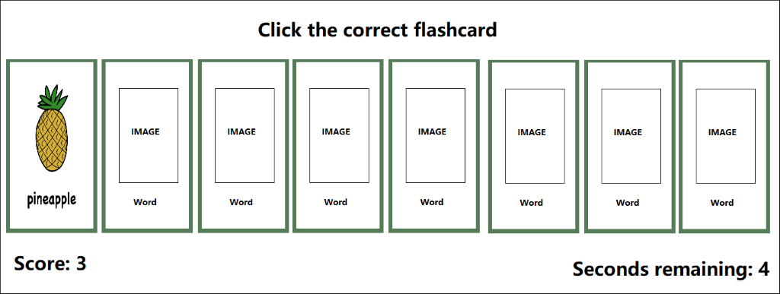

### The plan for the mini game ‘Memory’

A grid of flashcards is displayed, which is each of the six flashcards loaded twice, then distributed randomly on the screen. The flashcards are face down. The user will then click flashcards in pairs, looking for matches. As the card turns over, the audio plays. The user gets a point every time they correctly reveal a matching pair. The game has a timer that gives the user a time to beat for the round. The round ends when the user has matched all the pairs, or the timer runs out. A final score is given based on the time remaining as well as how many pairs the user successfully matched.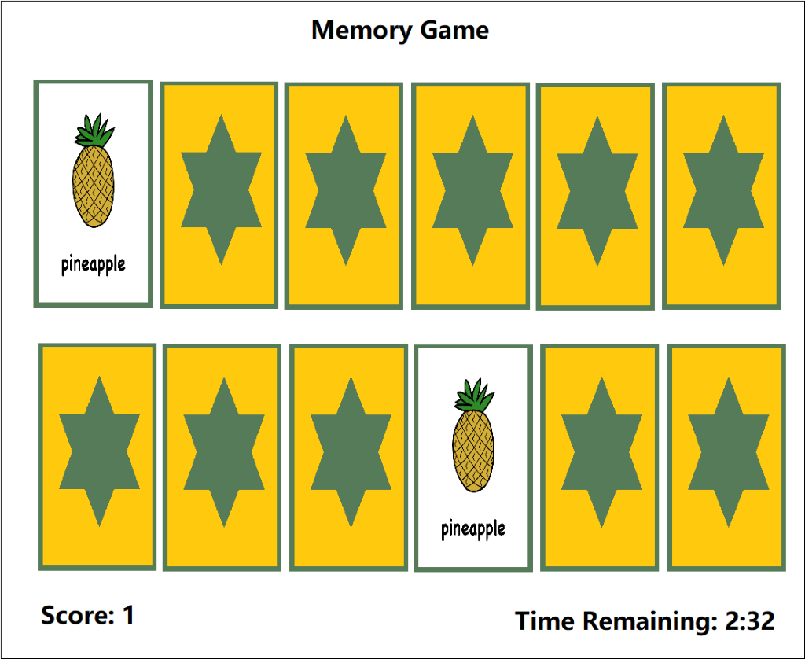

The plan for mini game ‘Word Match’

Similar to game 1, a grid of 10 images is displayed though this time just the image of the object is shown not the name of the object. The application will display the English name of one of the objects at the bottom of the screen below the cards, the user then has 10 seconds to match the word to the image by clicking on the correct image. After correctly selecting all the correct images the game will end or after 60 seconds has elapsed. Additional functionality could include displaying the name of the object in the user’s 1st language.

### The plan for the marketing presentation video

We will create a basic video advertisement for our flashcard system. The video will showcase all the features of our program as well as show a small sample video of a non-native child using this application.

### The plan for the website

We will create a simple website to show the product's features as well as allow the user to download the application onto their system. This website will show system requirements as well as documentation on how to use our software.

## Progress

### Programming Development

#### Setting up the Unity project

The project itself is created using the name ‘FlashCardSystem’. The settings were changed to 2D, rather than 3D as the program does not utilise the 3D engine of Unity.

#### Global Project Assets

The project itself will consist of several unity scenes, which are containers which hold the game objects alongside scripts. As of this version (v0.03), there are three scenes currently setup:

* ‘Main Menu’: The main menu users see when they enter the application.
* ‘Flashcard Selection’: The scene that allows users to select which flashcards they will use.
* ‘Mini Game 1’: A scene that plays a simple ‘Choose the correct flashcard’ mini game.

#### The main menu Scene

The main menu consists of a background image, an exit button, and a list of buttons for each mini game.

As of version v0.03, this is the current display that the user will see when they load the application:

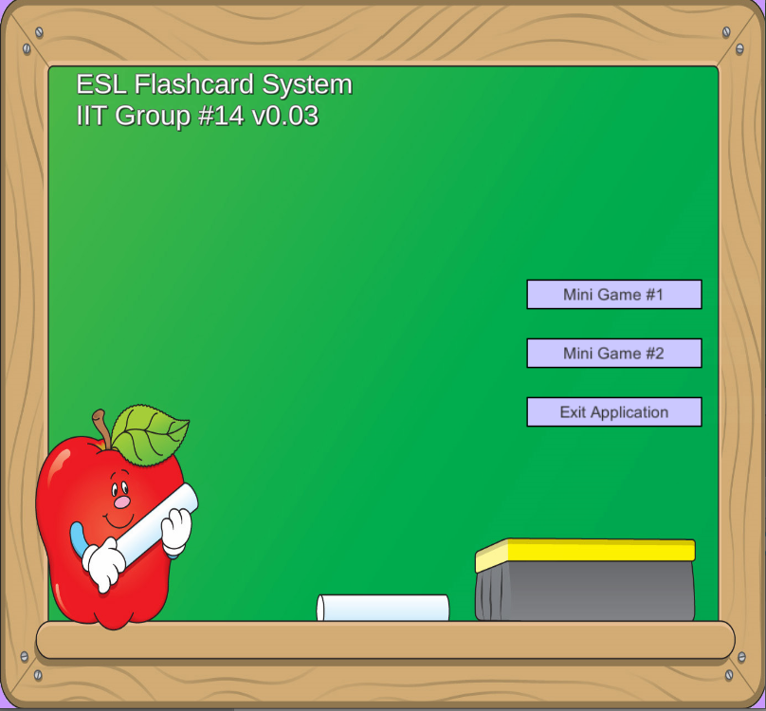

##### Scene Diagram:

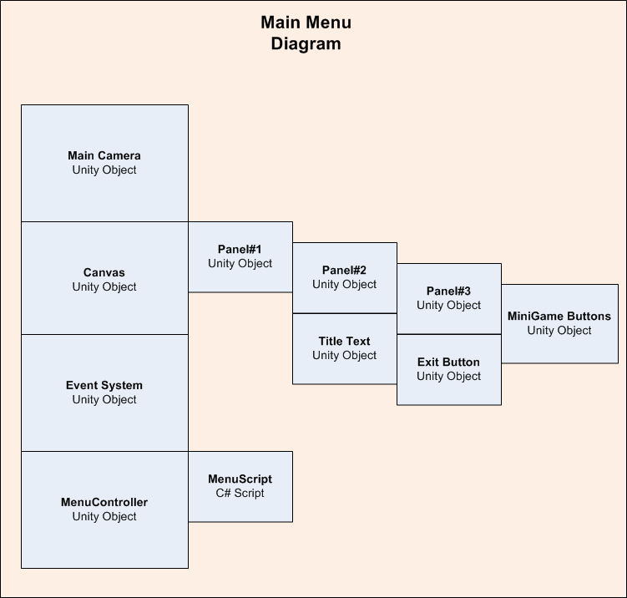

##### Main Camera

This is the main camera that focuses the screen, the settings were configured to use an orthographic 2D camera set to five units away to fit the main menu on the screen.

##### Canvas UI

This was created by using a unity ‘canvas UI’ object, and some smaller panels inside it. One panel is the overall large panel that displays the background image, the next panel is a smaller one to hold in the title text as well as the buttons. The reason UI is used is to ensure that no matter the screen resolution all objects will fit on the screen. Inside the Canvas UI is Panel #1. This panel keeps all the UI objects stretched onto the screen as well as holds a background image, sourced from the royalty free site (http://clipart-library.com). Inside Panel#1, is Panel#2. This panel holds the Title Text object which displays the title of our application.

Inside Panel#2, is Panel#3, which holds all mini-game buttons. These buttons are used to launch the minigame. They run a unity UI button touch function to launch a function on the ‘Menu Script’ C# script, depending on the button pressed. As of this version (v0.03), only one mini game is working so only the ‘Mini Game #1’ button is active. The exit button is simply there to load the ‘Exit Application’ function and quit the application.

##### Event System

This is a default unity object that is created to register clicks on the ‘Canvas UI’ objects and buttons, it is created by default and can be ignored for now.

##### Menu Controller/Menu Script

This is a unity object that is created to hold the Menu Script. The menu script controls button presses and sets up the system based on these presses to register the correct button pressed, saved the game selected in the global variables controller and then load the flash card selection scene.

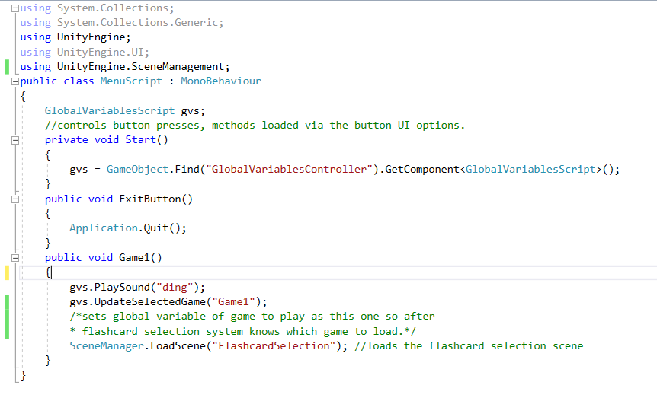

#### The Flashcard Selection Scene

The flashcard selection scene is loaded after a user clicks one of the main menu buttons. This scene has three general tasks:

1. Dynamically loads flashcards by pulling both images and audio from the ‘flashcards’ directory in the application root.
2. Displays the flashcards on a table of cards, with two rows, five cards per row.
3. Allows a user to select the ten flashcards they will use in the mini game they have selected.

As of version v0.03, this is the current display that the user will see when they load the flashcard selection area of the application:

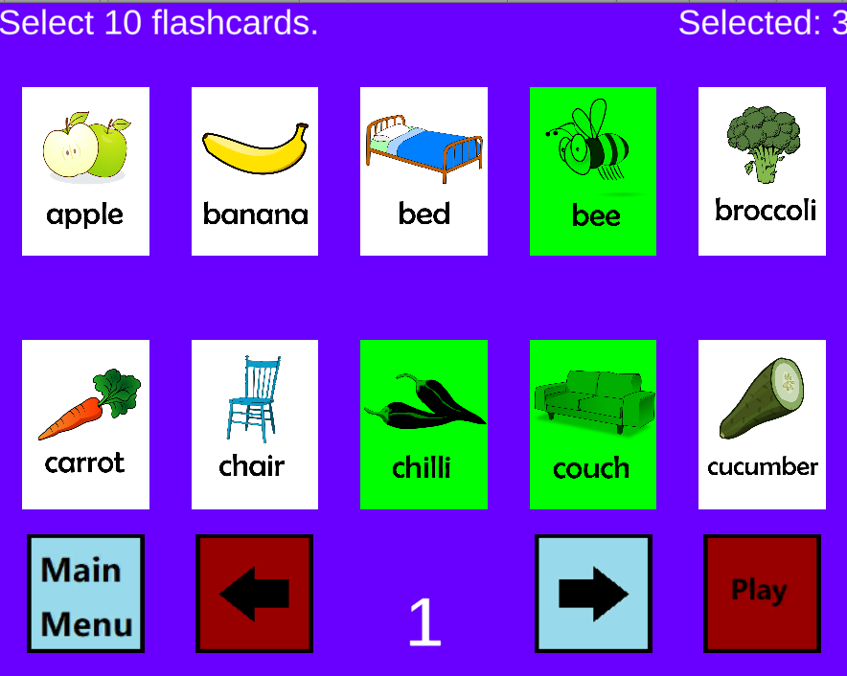

##### Scene Diagram:

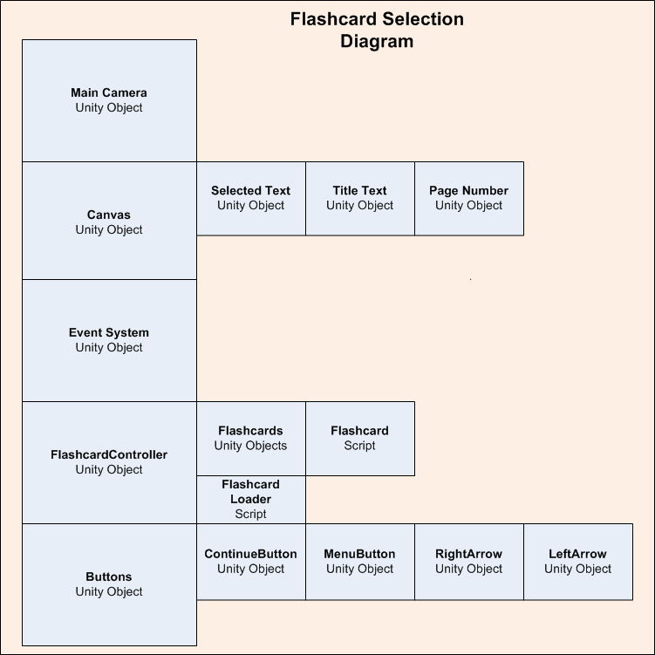

##### Main Camera

This is the main camera that focuses the screen, the settings were configured to use an orthographic 2D camera set to twenty units away to fit the main menu on the screen. This is a difference in distance as opposed to the main menu

##### Canvas UI

This was created by using a unity ‘canvas UI’ object, in the flashcard selection scene it is simply used to display the three different text objects, ‘Selected Text’ which tells the user how many flashcards they have already selected, ‘Title Text’ which tells the user to select ten flashcards and ‘Page Number’ which shows the current page of the flashcards you are viewing.

##### Event System

This is a default unity object that is created to register clicks on the ‘Canvas UI’ objects and buttons, it is created by default and can be ignored for now.

##### Flashcard Controller / Flashcard Loader Script

This is a unity object that is created to hold the Flashcard Loader Script. The flashcard loader script is responsible for reading all files in the applications root directory, flashcards folder and creating the unity game objects for these flashcards.

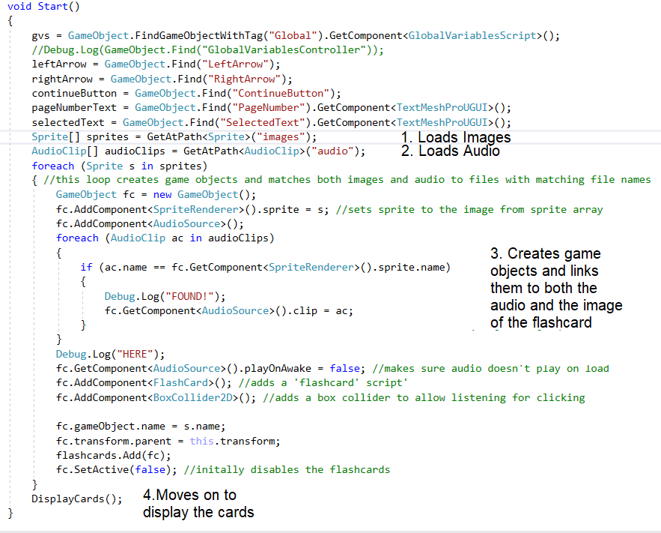

1. Loads all images in the /application directory/flashcards/images/ folder.
2. Loads all images in the /application directory/flashcards/audio/ folder.
3. Matches these files together and creates flashcard objects that will have both the image and the audio files.
4. Moves on to the display cards method.

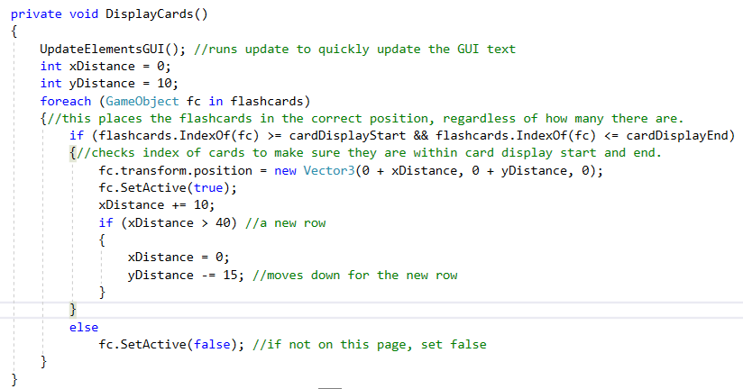

Here the application displays all the created cards in two rows, with five cards per row. If there are more than this, they will not be loaded unless the user changes the page.

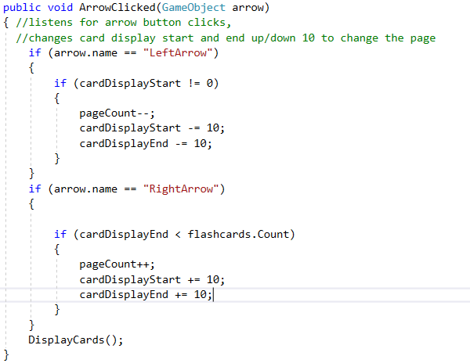

Here the application awaits either ‘Left Arrow’ or ‘Right Arrow’ buttons to be pressed, it then changes the page of the flashcards the user is viewing. If the user is already at page 1, it will not allow the user to continue going back, as well as if the user is at the end of the flashcards, the user will not be allowed to continue forward.

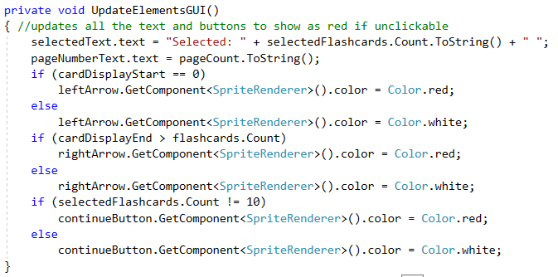

This Update Elements GUI function is run every every time a button is pressed to update the graphics user interface (GUI) of the user. It changes arrows to red if they are unavailable to be pressed, as well as the continue button to red if the user has not selected enough flashcards to proceed. It also increments the selected flashcards text so the user can see how many flashcards they have already selected.

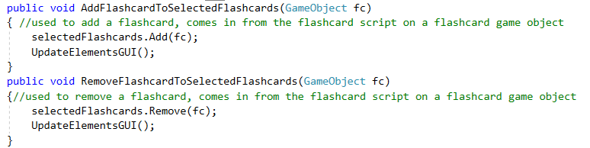

These functions come in from the flashcard scripts on the flashcard objects and add/remove them from the selected flashcards list. The selected flashcards list is used to be passed into the next scene, the selected game from the main menu, so that the users correct flashcards are used when they play their selected mini game.

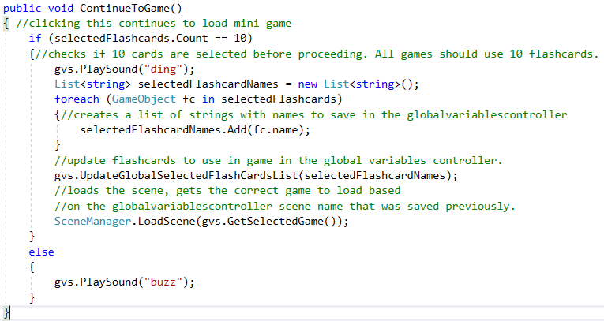

This Continue to Game function is used when the user clicks the ‘continue’ button the GUI. It first checks if the user has selected 10 flashcards, then proceeds to save the name of all the selected flashcards and saves them in the global variables controller to be carried onto the next scene. If the user has not selected 10 flashcards, the user will hear a buzz and not be able to continue.

##### Flashcard Game Objects / Flashcard Script:

The flashcard game object has both an image an audio attached to it. It is created by the flash card loader script. This is the game object that physically shows up as card in the game itself.

Here is an example of two of these objects appearing in the flashcard selection screen.

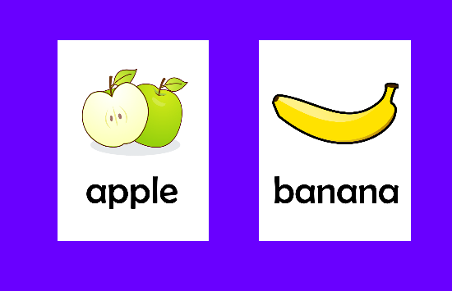

Attached to these flashcard objects is ‘flashcard’ script. This handles users' interactions with the flashcard's game objects.

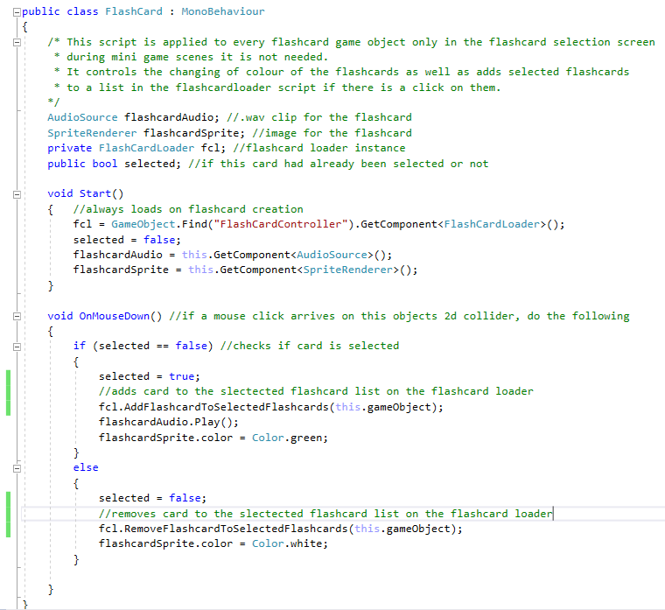

The flashcard script simply listens for a click on the flashcard game object, then sends passes itself to the flashcard loader script when pressed. If it has already been pressed, it sends the request to deselect it.

#### Game #1 Scene

This game is created with the following configuration, first the user hears audio from one of the cards at random, then they must click on the cards. If they click the incorrect card, it turns red and one point is deducted. If they hit the correct card, a point is added, and a new cards audio is played. The user has 60 seconds to get as many points as possible. When the time runs out, the user can no longer click on anymore cards.

Here is an example of the Game # 1 scene as of v0.03.

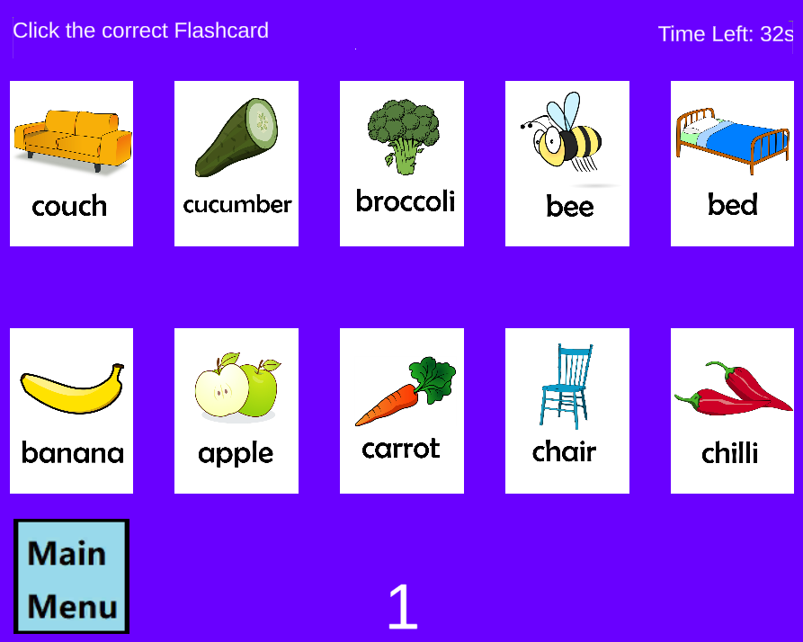

Here is the diagram for game #1.

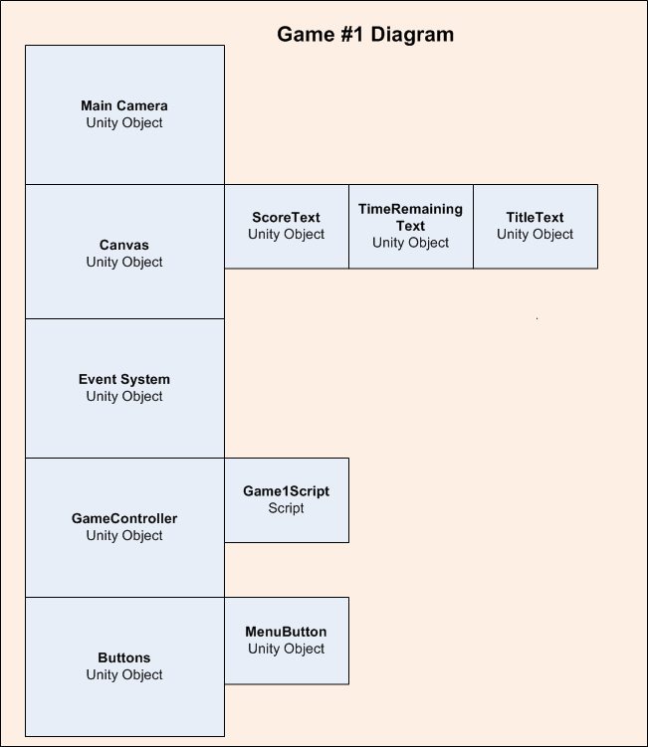

##### Main Camera

This is the main camera that focuses the screen, the settings were configured to use an orthographic 2D camera set to twenty units away to fit the game #1 scene

##### Canvas UI

Three text components are here, used to display the score, the time remaining and show the title text.

##### Event System

This is a default unity object that is created to register clicks on the ‘Canvas UI’ objects and buttons, it is created by default and can be ignored for now.

##### Game Controller / Game 1 Script

This is a unity object that is created to hold the Menu Script. The menu script controls button presses and sets up the system based on these presses to register the correct button pressed, saved the game selected in the global variables controller and then load the flash card selection scene.

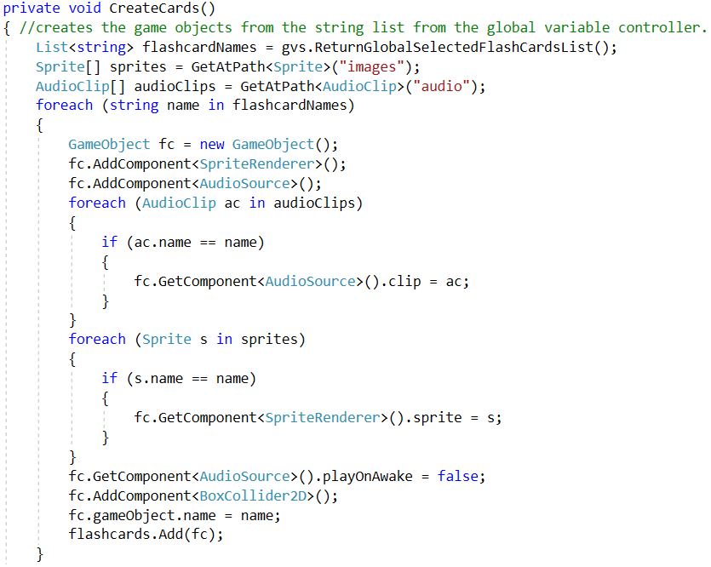

This Create Cards method runs through and loads cards and image files from the folder based on what was passed through during the flashcard selection screen.

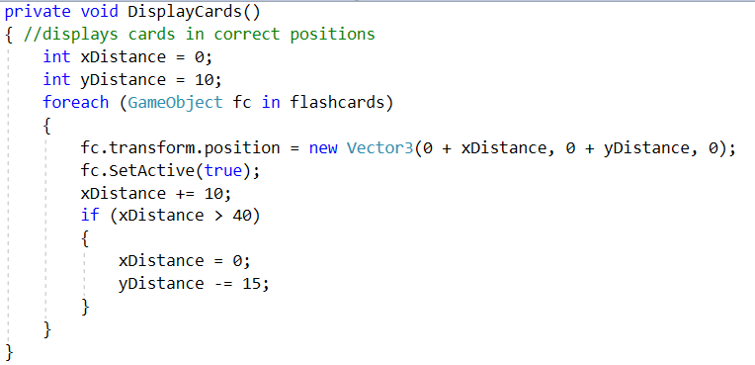

This Display Cards method sets the cards in a 2x5 grid on the game playing area, and adds it dynamically to allow a change in the amount of cards later on if the project design changes.

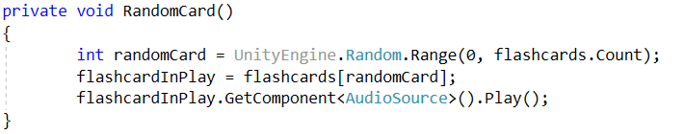

This method is run every time a flashcard is correctly selected to choose a new random card for the user to find.

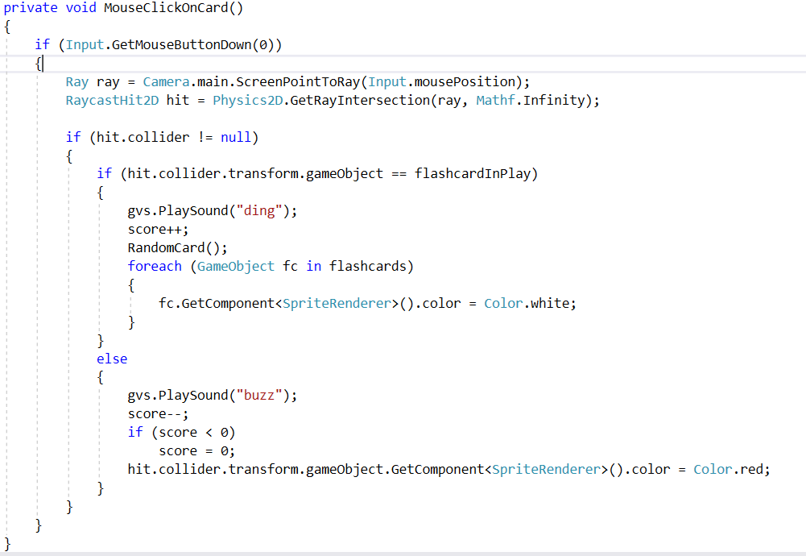

This method is run when the mouse is clicked on a card to either give a ding and add a point if the card clicked is correct, or a buzz if the card clicked is incorrect. If the card is incorrect, the card will change colour to red to allow the user to know that the card selected was not the correct card.

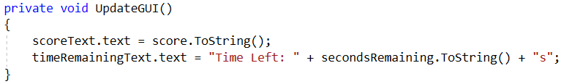

This updates the user's graphics user interface to show seconds remaining as well as update the users score.

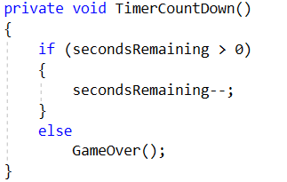

This is the timer that counts down the seconds, if time runs out the game will progress to game over.

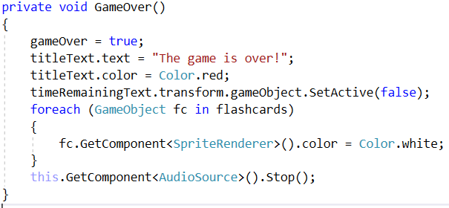

This method is run to ensure the game stops and the users score is finalised at the end of the round.

#### Application version log:

##### V0.01

--Creation of Unity Project.

--Creation of Main Menu Scene.

--Creation of Buttons for Main Menu.

--Creation of Main Menu UI.

--Creation of Main Menu Controller.

--Basic Main Menu Scene completed. Will need to revise and update in a later version.

V0.02

--Creation of flashcard selection scene.

--Creation of flashcards selection buttons.

--Creation of flashcard loader script.

--Creation of the flashcard script.

--Flashcard Selection scene complete.

V0.03

--Creation of Game #1 Scene.

--Creation of GameController.

--Creation of Game1Script.

--Game #1 Scene complete.

#### Programming still to do:

##### Flashcard dynamic loading issues

The flashcard software must be able to load flashcards dynamically by the user AFTER the project is built from the source files, however right now flashcards can only be added before the project is built. This is a bug and problem in code design which needs to be resolved, we are looking into how to do this now.

##### Game # 2-?

The project still needs the addition of more mini games, starting firstly with the planned-out memory game that will need to be created. This can be created following the similar pattern of how game # 1 was created.

##### Game # 3-?

A planned 3rd mini-game is to be created, in addition to the ‘memory’ game. This can also be created following the similar pattern of how game # 1 was created.

##### Cloud integration and downloading and sharing of flashcard packs

Another planned feature is the idea of sharing flashcard packs. An upload and download function would need to be created on a cloud repository with unity3D functions set to be able to load these at will.

## Assets Acquisition and Creation

In designing the flash cards, I interviewed a New South Wales primary school teacher to determine appropriate content, so that they would be beneficial for preschool and kindergarten classes learning English as second language.

Subsequently I decided to use common nouns in 5 different categories. These could be used as sight words for reading, or for classification activities. In order to determine the correct format, I researched fonts used in schools and those that have optimum readability. For this reason, I chose the font Berlin Sans Fb.

For the voiceovers I commissioned a professional voice actor to record the words ensuring the clearest articulation and audibility. Clear articulation for young listeners is essential, especially for the high frequency sounds. The flashcard artwork is royalty free and chosen for its simplistic style and cartoonlike appearance which would appeal to young children. Each flashcard is 750x 1000 pixels to ensure a correct fit within the app. The website link is: [https://pixabay.com](https://pixabay.com/)

## Testing and QA

#### V0.01 QA Session #1

Tester 1

Application opened ok, did notice the menu didn’t resize properly and so was marked as a bug. Seemed a bit slow to exit once hitting the exit button.

#### V0.02 QA Session #2

Tester 1

Flashcard selection worked fine but the game 2 button was not working, but it is in development. Sometimes flashcards doubled up. Also, cannot add your own cards in the folder, the flashcard software doesn’t load the new cards?

#### V0.03 QA Session #3

##### Tester 1

Everything worked as normal, the flashcard doubling up still sometimes occurred as well as the game 2 button was still not accessible, but that feature is not developed yet. No major bugs were found, and the game seemed to run smoothly enough and loading the flashcards from the flashcard folder still doesn’t work. One issue was a slight delay with the ‘buzz’ sound sometimes coming up at weird intervals unrelated to the game playing itself.

##### Tester 2

As the game is a basic children's game, the background type for the game's tester could be anyone who is able to notice any basic errors as the prototype of the game. As we have IT skills across a broad range in the group any member can test and also mention enhancements to the game. It is possible that a few versions of the game could be made after some prototype changes.

The games files themselves are sitting in their own unique game folders with pictures and sounds, so it makes it simple that a user doesn’t click on the wrong file to open and start the game. Generally, you could create a desktop icon. The main screen itself has no main bugs at this stage of the development of the game, the only issue that might be considered from some criteria is the amount of green space between the tomato pictures and the games buttons.

The second mini games button doesn’t work at this stage but the second game is still under construction so this will be corrected in the next games update of the prototype. The first option to load up the game works as intended. After the game is loaded each sound for each animal work as intended and no further corrections will be needed for this, the time on the game works as it should as well. The only main bug I could find through playing at this stage was that the animal cards you would have to select would often double up, this could be a creation of the game but it was happening a bit so could be considered a potential bug.

So far, the majority of the prototype works as it has been designed.

Tester 3  
Main Menu functions correctly, although menu option size could be increase as on a smaller screen it may be difficult to read. Mini-Game #2 is not yet functional, so the button for it does nothing as of yet. In Game #1 the “Chair” card does not have an associated audio file attached to it so it does not play, seeing as the game uses audio cues to play this makes the chair card unusable in it’s current state. Page 3 on the card selection screen currently empty, this should be removed if it is to stay empty, or additional cards should be added to fill this screen. The game also repeats the flashcards rather than ending once all have been correctly selected.

## Project story so far

The project has been coming along smoothly, some changes in design have been noted such as the idea to implement cloud flashcard decks into the program. We have not designed any flashcard categories or sorting systems yet but have also decided to add this into the program. Some problems we have encountered is the large file size and difficulty sharing work amongst the group, we have opted for Unity3D collaboration to try and help collaborate changes better.

We are now at the point where the basic weekly timeline has been met and are looking forward to continuing this project even after the module is over.

## Problems

We still have a problem with dynamically loading flashcards, right now they are loaded from the ‘resources’ folder in unity3d however new flashcards cannot be added after the project is built. We have tried a few different methods but are still working on a way to resolve this issue as the program does need to be able to dynamically load flashcards.

## Handover

If another team was to take over at this point, they would have a couple of main points to follow up:

* Fixing the issue of dynamically adding flashcards AFTER the project is built. Right now flashcards can only be dynamically added by adding them to the source code before building.
* Cloud integration (Planning and execution for downloading and uploading flashcard decks).
* Expansion of flashcards assets.
* Adding background music and images.
* Creation of a second or more mini games.

# Roles

For our group we have decided not to go with individual roles, but with section the work into categories of work that need to be done. We have identified six categories that will need to be completed. The reason we have chosen this approach as opposed to singular roles is so that people may take up multiple tasks and roles if they wish to do so. Here are the categories we have chosen to go with, all work in our timeframe as well as project progress will also be separated into these roles if they are applicable.

## Admin

This will consist of all organisation on our platforms, including Trello/slack/discord/GitHub, meetings, the document report as well as all other admin related tasks. Another task falling under this category is the compiling and quality control of our reports and documents. This will also include the work on the rest of the document less related to our project, for example the team profile section on our main document.

## Programming

This will consist of all work related to programming and development and will mainly focus on the use of Unity3D to create the actual application as well as creating logs. Programming will also be responsible for documenting, screenshotting and explaining our development process so it is easy for another team to pick up our project.

## Assets acquisition/creation

This will be all asset acquisition and creation. This involves creating the flashcards, recording audio, finding background images and any other graphics/audio we might need for our project. This will also encompass the creating of a progress report for this process and have we have managed so far.

## Testing/QA

Testing will be all testing and QA on our application project, as well as the creation of reports showing testing and QA information.

## Website Creation/Updating

This will be work related to the updating of our GitHub page to reflect all the new content generated by Assignment 3.

## Presentation Video

All work related to the creation and storyboarding of our presentation video for our application.

# Scope and Limits

The general scope of this project does seem to be possible to do in the allotted time, as the project itself is reasonable for six people to create. We have, however, placed some limits on creating this application to deal with scope creep and help us meet and manage our time and work commitments on this project.

One of these limits has been the number of mini games we will produce, as it stands now, we only plan to add two. Ideally, if time and scope constraints weren’t an issue, we would want to add many more mini games to the application.

Another limit on our project is the number of flashcards we will create and supply with the application. A set of twenty is a rather modest number. Ideally, we would have many more. An ESL flashcard application such as this should have at least 200 or so cards in a stock version. We plan an enhancement where the users may create their own flashcards, but we would prefer more flashcards bundled with the stock application.

# Tools and Technologies

Our project will require a small collection of different hardware and software to achieve our goals. We have listed below the hardware and software that we need and the experience within the group using these tools.

## Software required:

* Unity3D (v2019.2.17f1) - License is free for non-commercial use and educational use. Used for creating the actual application using the Unity3D framework.
* Microsoft Visual Studio (v15.9.17)– License is free for non-commercial use and educational use. Used for the programming aspects of the application development in conjunction with Unity3D.
* Gimp (v2.10.8) – License is free for non-commercial use and educational use. Used for flashcard image creation.
* GitHub – used to help us collaborate our work and host our website under a GitHub page.
* Trello – used to help us organise our workload.
* Slack – used for all text correspondence between the team
* Discord – used for our weekly voice meetings.
* DaVinci Resolve (Video Editing Software)
* Dreamweaver, Notepad ++ text editor.

## Hardware required:

* A computer capable of running Unity3D and Microsoft Visual Studio.
* A microphone for recording sound for the flashcards.
* An internet connection to allow online collaboration between the group.

## Group experience:

Jason Walstab – I have experience at a hobbyist level for Unity3D and Gimp and experience at a professional level for Microsoft Visual Studio (primarily in .NET and C#).

Jake McAndrew – Experience in java and python, basic knowledge of photoshop and other photo editing software as well as knowledge in voice recording software (audacity).

Tim Damon – Experience in Java and C#, hobbyist level experience in Unity3D (Game development), Gimp (photo/image editing), DaVinci Resolve (Video editing) and OBS (screen recording/video editing).

Jason Tilgner – Experience in Java and Csharp, photo / image editing, sound editing.

Sean Lottey - I have experience in HTML using Dreamweaver and experience in game design using the Unreal 4 engine.

Anthony Brown – Experience in web programming + HTML, windows movie maker and GitHub.

# Testing

Our group plans to do testing each week during development using QA (Quality Assurance) sessions. Each week a new feature will be added to the application. The programmer will initially do basic testing.

A dedicated project member will do a follow-up QA session. In this session, they will test the program and write up any errors, issues or problems they find. The programmer will then be able to follow up. If the dedicated QA tester encounters a serious problem, the programmer will schedule in another testing session before moving on to add the next applications feature.

The development team will maintain a testing log to ensure that all issues found by QA will be followed up by the programmer.

# Time Frame

|  |  |  |  |  |  |  |  |
| --- | --- | --- | --- | --- | --- | --- | --- |
|  | **Monday** | **Tue** | **Wed** | **Thu** | **Fri** | **Sat** | **Sun** |
| **1** | Project Planning: Overview | Project Planning:  Ideas | Project Planning:  Roles | Project Planning:  Execution | Project Planning:  Planning | Project Planning:  Tools | Project Planning:  Review |
| **2** | Discord Meeting (8PM) | S: Main Menu | S: Demo Video Draft |  | E: Main Menu | S: Flashcard images set (+20 cards) | S: QA Session #1 |
| **3** | Discord Meeting (8PM) | E: QA Session #1 | E: Flashcard images set (+20 cards) | S: Flashcard Audio (2) | E: Demo Video Draft | E: Flashcard Audio (2) | S: Demo Video Final |
| **4** | Discord Meeting (8PM) | S: Flashcard Selection System | S: Basic Website Creation |  |  | E: Flashcard Selection System | S: QA Session #2 |
| **5** | Discord Meeting (8PM) | E: QA Session #2 | S: Mini-Game #1 |  |  | E: Mini-Game #1 | S: QA Session #3 |
| **6** | Discord Meeting (8PM) | E: QA Session #3 | E: Basic Website Creation | E: Demo Video Final | S: Finalise Project Report |  | E: Finalise Project Report |
| **MODULE TIMELINE EXCEEDED, BELOW THIS LINE IS FOR FUTURE PLANNED WORK** | | | | | | | |
| **7** | Discord Meeting (8PM) | S: Mini-Game #2 |  |  |  | E: Mini-Game #2 | S: QA Session #4 |
| **8** | Discord Meeting (8PM) | E: QA Session #4 | S: Flashcard images set (+80) |  |  | E: Flashcard images set (+80) |  |
| **9** | Discord Meeting (8PM) | S: Catch up week |  |  |  |  | E: Catch up week |
| **10** | Discord Meeting (8PM) | S: Cloud integration planning |  |  |  | E: Cloud integration planning |  |
| **11** | Discord Meeting (8PM) | S: Cloud integration coding #1 |  |  |  | E: Cloud integration coding #1 |  |
| **12** | Discord Meeting (8PM) | S: Cloud integration coding #2 | S: Improved website planning |  | E: Improved website planning | S: Cloud integration coding #2 | S: Improved website Creation |
| **13** | Discord Meeting (8PM) | S: QA Session #5 | E: QA Session #5 |  |  | E: Improved website Creation |  |
| **14** | Discord Meeting (8PM) | S: Coding refactoring/cleaning | S: Assets polishing |  |  | E: Coding refactoring/cleaning | E: Assets polishing |
| **15** | Discord Meeting (8PM) | S: QA Session #6 | E: QA Session #6 | S: Final website |  |  | E: Final website |
| **Work Categories** | | | | | | | |
|  | Areas of work: | Admin | Programming | Assets acquisition | Testing/QA | Presentation Video | Website |

## Week 1

This week will consist of planning the entire project and deciding what exactly we want to achieve, as well as plotting out our basic timelines and setting work into different categories for us to complete.

## Week 2

This week will commence with the creation of the main application with a basic main menu, along with the starting of the video draft and the starting of acquiring assets required to create twenty stock flashcards, and a start of a QA session to start to look for bugs and issues with the first build.

## Week 3

This week will commence with the conclusion of the first QA session, as well as the first twenty flashcards being completed with both images and audio. The video draft will also have been completed and the final video work being started.

## Week 4

Work on coding and creation of the flashcard selection system will both start and be finished in this week. Basic website will be started and at the end of the week a QA session will begin to check the newly created flashcard selection system.

## Week 5

This week we will finish our second QA session with the newly created flashcard selection system, then move onto creating the first mini game for our application. This should be finished this week and then the QA session for this newly created mini game will begin.

## Week 6

This week QA session #3 of the first mini game will be completed, and the basic website should have been created alongside our final video. We will then work on finalizing our project report for handover/marking.

## Week 7

This week work will begin on the second mini game ‘memory’, after this is complete another QA session should commence to check this progress.

## Week 8

QA session #4 will be complete, and asset acquisition/creation will begin for another set of 80 flashcards.

## Week 9

This week will be dedicated to reviewing the application, changing any systems or plans that aren’t now acceptable due to scope change as well as catching up on any work that may not have been completed on the project.

## Week 10

We will begin planning the cloud integration features, i.e finding a suitable cloud provider, drawing up diagrams of how to integrate it to our program and looking at pricing structures and feasibility of using a cloud technology to host custom flashcards.

## Week 11

This week we will begin the first stage of cloud integration programming stage, providing it is feasible for us to do so with this project. It will be the setting up of a cloud server and changing the application to read from a cloud server folder instead of the local hard drive.

## Week 12

A second stage to cloud integration programming will begin, focusing on troubleshooting, changes and setting up categories and folders for users to pull from, as well as an upload feature. We will also start to plan an improved product website and begin the creation of this website.

## Week 13

This week will commence with another QA session to check and improve the cloud integration components of our project as well as a completion of improving the website with new product information.

## Week 14

This week will focus on cleaning up all coding bugs, refactoring and commenting and general polishing of the program as well as adding and improving assets such as background images and music in the program.

## Week 15

A QA session will be held to test the new code refactoring and assets that have been added, as well as a more final website will be created to reflect and show the changes.

# Risks

## Scope too large

There is a risk that the scope of the project is too large for us to manage. While we will diligently try to pursue this task of creating an ESL flashcard system, the project might be too big, and we will not be able to finish or meet time constraints for our project. We should try to minimise this risk by sticking to and meeting deadlines as well as following a well-organised structure that will come from good project planning and not procrastinating on tasks we individually need to complete.

## Programming issues

The programming skills for the collective group will not be enough to complete the project.

We may not have the expertise to complete essential components, such as the dynamic flashcard loading system. This case would be a critical failure, as we could not then achieve any of the functionality that relies on the essential component.

We may not have the expertise to complete additional features. Once we have completed the core functionality, we may find we cannot complete the enhancements we have documented. This case would be less critical, but the impact on the overall value of the final product may be substantial.

## Application Quality

The end product may not be of high enough quality to be palatable to potential clients. We may complete a functional app by following our plan and meeting the technical and logistical challenges but have a product that is unfavourable to the potential clients. If the final product does not present well and is easy to use, then it will face poor take-up rates with clients.

## Market Saturation

We may not get a good take-up rate in the marketplace because of the number of competing applications. The market for ESL learning tools is already quite large. Although we envision a target section within the market, our app may fail to be recognised.

## Reaching the end-users

Our application may not reach the intended users. Our intended users will primarily be non-native English speakers living in remote locations in foreign countries. We can devise an advertising strategy, but it is a complex market segment to target. Our advertising approach may not work.

## Too difficult to use

Our application may not be useful to the end user because it is not easy to use. We may find the app intuitive, but our clients are different from us and they might not feel the same way.

## System requirements too high

Our app will not be able to be run on systems our clients currently have. Our application is primarily for people in areas that lack modern technology and they may be running technology generations behind ours. We might find we are accessing technologies that their systems cannot support.

# Group processes and communications

Our group has decided on three main methods of communication, those being:

* Slack
* Discord
* Trello
* GitHub

Slack is what we use primarily for basic organisation, image sharing and text communication. This is at the heart of our group's communication methods. We always make sure to stay online on slack and even though we are in different time zones this has been a great way to focus our efforts and communications.

Once a week on Monday night we have a Discord voice chat meeting, to discuss issues and plan for the next week in advance. This is good to help us touch base and make sure everyone is on the same page, most meetings so far have been a success despite people's busy schedules.

Trello is what we use as our main planning board as well as keeping a list of checked jobs and to make sure everything is on track and planned for. We have a good system of marking job cards as ‘underway’ and ‘done to make sure no one is doubling up on tasks.

GitHub is how we are sharing and collaborating on documents that we need to produce. In the end this was used less for collaboration and more used in the final stages of compiling to ensure our project can be compiled and put together with ease and in an organised manner.

# Skills and Jobs

## Position 1 – Project Manager/Team Leader

We would need a Team leader or project manager with experience in managing small teams, meeting deadlines as well as organising resources for the team. This position will require good communication and organisation skills as well as a familiarity with application development processes and the ability to generate good looking, clear and readable graphs, charts and reports for the group.

### Preferred Experience

* At least one year managing a small team in an IT related field.
* One to two years' experience with project management.
* One to two years' experience with App development processes.

### Generic Skills

* Leadership.
* Team player.
* Organisation.
* Communication.

### IT Skills

* Knowledge of a project management app such as MS Project would be a huge bonus.
* High ability in the MS office suite, including Word, Excel and PowerPoint.

## Position 2 – Programmer

Another required position is for a programmer to develop the app as well as well work on the project website. We would be looking for someone that is comfortable and able to program especially with experience in the game development area with a flair for creativity and the ability to work according to the project guidelines and requirements. Another requirement is to be able to write clear and concise documents if a handover of the projects code was required as well as the ability to work with the marketing team to create a functional website.

### Preferred Experience

* At least one year in the game development sector.
* At least three years' experience programming in C#.
* One to three years' experience working with a game engine such as Unity3D or Unreal Engine 4.
* Experience working with a cloud service provider such as AWS or Azure.
* Basic experience in web development.

### Generic Skills

* Able to meet deadlines.
* Good documentation and literacy skills.
* Great analytical and troubleshooting skills.
* Good creativity skills.

### IT Skills

* The ability to write code in C#.
* Knowledge and the ability to create applications in game engines such as Unity3D and Unreal Engine 4.
* Able to use GitHub in a professional capacity.
* HTML5 and CSS skills.
* Cloud server technology.

## Position 3 – Artist

We will also need someone for asset acquisition and creation, primarily in graphics and sound. This position will be focused on the creation of all images, sounds and music for our project. An artist with a broad range of experience and talents would be needed to fit this bill. They would also be required to work with marketing in the creation of promotional videos as well as with the programming team to make sure their assets match the requirements of the application.

Preferred Experience

* At least one-year experience creating children's style drawings and images.
* Any experience with sound editing or music production.
* At least one-year experience working with a graphics design app such as Gimp or Photoshop.

### Generic Skills

* Amazing creativity skills.
* A multitasker with many creative talents.
* A good ear for music.
* A good eye for art.
* Good communication skills.

### IT Skills

* Great Photoshop or Gimp skills.
* Ability to record and manipulate sound and music digitally

## Position 4 – Marketing

A final position for our group will be a marketing position. This role will involve market research, advertising the product over the internet or locally, making connections with schools and businesses, directing advertising materials such as video promotions and the products websites written content as well as conduct marketing campaigns online via social media. This position will need to heavily co-ordinate with the artist position to create great marketing materials.

Preferred Experience

* At least one-year experience in a sales role.
* Experience with working in an ESL environment a bonus.
* Experience with writing professional marketing materials and advertisements
* Bonus experience with video editing would be great.

### Generic Skills

* Great people and communication skills.
* Being fluent in two or more languages.
* A good grasp on a foreign culture or market that needs ESL resources.
* Excellent writing skills.

### IT Skills

* Ability to put together digital resources such as pamphlets.
* Ability to put together videos.
* Good understanding of internet and social media technologies.

## Group Feedback

## Anthony Brown

### What went well?

I believe we had a group of people that wanted to make the group work and were prepared to work to that end. This was reflected in our ability to be decisive by sharing our opinions and then respecting the group consensus.  Once a decision was made everyone effortlessly moved to the next work item.

### What could be improved?

I found our communication channels a bit stinted.  We took a while to find the communication methods that suited the group. We could have been more productive in the middle part of the project. If we had got our communication working better earlier then we may have avoided this.

### At least one thing that was surprising?

We all occupy different time zones and have different work requirements. This didn’t cause nearly as much problems as I initially thought it might. Remote communication helped us deal with it. Each member could pick up where the last had left off.

### At least one thing that you have learned about groups?

Groups work best when everyone one is contributing.

## Tim Damon

### What went well?

The group was very well organised, using several different outlets for the organisation such as Trello, Slack, Discord and GitHub. Everyone picked up several parts of the project to complete themselves, agreeing to collaborate it all through GitHub. We had a clear list of tasks and who was assigned to what through the Trello board setup by Anthony.

### What could be improved?

Tasks assigned could be completed more quickly (myself included). More consistent group chats (through Discord) as we only got together a few times and it was never able to be all of us at once.

### At least one thing that was surprising?

How easy it was to organise everything with each person in the group without ever getting to meet face to face. Trello made creating a list of tasks and assigning them incredibly easy and that list was always there so you knew what needed doing and who was doing what.

### At least one thing that you have learned about groups?

That each individual putting in effort helps everyone else work load and that organisation is key, effective organisation can turn a large task into something much more manageable.

## Shaun Lottey

### What went well?

I feel that all members of group were well organised and great communicators. Thanks to tools provided by different members such as Trello, we were able to quickly and effectively organise what seemed a colossal task into a much more manageable agenda. Group cohesion was almost effortless when assigning tasks or implementing ideas.

### What could be improved?

Due to the timing of the year with Christmas, it was difficult for us all to remain in constant contact throughout. A more regimented communication schedule, like a set few times each week to catch up would be beneficial to us, although this is difficult with conflicting work schedules.

### At least one thing that was surprising?

Honestly, how easily the group worked together. Each task was put before us, assigned and completed with people asking for help if they needed it, and help being given in kind. For the limited times we were all able to speak live it was an outright pleasant experience.

### At least one thing that you have learned about groups?

Team work makes the dream work. Knowing you have the support of your peers makes daunting challenges a lot more manageable.

## Jake McAndrew

### What went well?

I feel our group was very well organised, I’ve never used trello before, but it was a very useful tool to keep up to date on what needed to be done. Even though I found it very difficult to be online at the same time as the other group members due to my work schedule, I still feel like I always had clear direction on what needed to be done thanks to other team members.

### What could be improved?

I feel like the team worked pretty well together, the only major improvement I can see has to do with my personal time management and being more involved in group calls and discussions.

### At least one thing that was surprising?

One thing that was surprising was how organised and friendly everyone was. I have never done group work over the internet before and I was very surprised how smoothly everything went even with my limited time.

### At least one thing that you have learned about groups?

Group work is so much easier when everyone communicates and is organised

## Jason Tilgner

### What went well?

The team had some good organisation every was keen to get into the assignment, we probably didn’t have much of a structure at the start but Anthony was able to organise us and sort of become our team adviser. We used some different industry tools to be able to organise and set up a clear schedule, on who had to do what and when. Everyone was able to complete their part and make proper updates into GitHub. Some of the tools we used where trello, slack, and discord. It was also interesting to see everyone’s different industry views.

### What could be improved?

Just a bit of hesitation at the start to get tasks started and probably not spreading them out as late as we have. At some points it felt like it was taking a bit long on certain tasks.

### At least one thing that was surprising?

How easy and quick it was to organise everyone to get in communication to work out tasks and who was doing what. That everyone went off and did the task required, and generally above what was required. That members asking for each other opinions or asking for help if unsure, instead of just doing their own thing.  
At least one thing that you have learned about groups?  
That being organised at the start helps and that having helpful + willing team mates makes everything a lot smoother.

## Jason Walstab

### What went well?

Making the prototype and the general teamwork of putting it altogether went extremely well, as there were many different moving parts and it was difficult for us to manage it all. The report was also difficult to write however we managed to get it altogether on time, which was a great achievement, I think.

### What could be improved?

Following plans laid out and not deviating to much from what we set out to achieve. Over the project we had to decide and change and work together on many small things which sometimes made this rather difficult.

### At least one thing that was surprising?

The coming together of the presentation video was quite good as I was worried about this side of the project. I was very surprised as the quality and hard work put into the video presentation and happy with how it turned out in the end.

### At least one thing that you have learned about groups?

I have learned that working in groups is a difficult but rewarding task and that to ensure good quality work a team must work together to achieve their goals. This alongside organisation and good communication being a key part of group work.

## References

eLearning Industry. (2020). *10 Best Language Learning Apps For Kids - eLearning Industry*. [online] Available at: https://elearningindustry.com/10-best-language-learning-apps-for-kids [Accessed 31 Jan. 2020].

News 2020, "Vietnam lacks teachers to achieve language targets", *Thepienews.com*, 2020. [Online]. Available: <https://thepienews.com/news/vietnam-teachers-language-targets/>. [Accessed: 08- Jan- 2020].

Research, 2020, "English Language Learning Market to grow at 7.1% to hit $54.8 billion by 2025 – Insights on Recent Trends, Size, Share, Growth Opportunities, Key Developments and Future Outlook: Adroit Market Research", *GlobeNewswire News Room*, 2020. [Online]. Available: <https://www.globenewswire.com/news-release/2019/07/26/1892347/0/en/English-Language-Learning-Market-to-grow-at-7-1-to-hit-54-8-billion-by-2025-Insights-on-Recent-Trends-Size-Share-Growth-Opportunities-Key-Developments-and-Future-Outlook-Adroit-Mar.html>. [Accessed: 08- Jan- 2020].

Taylor, 2020, "People around the world still think English is the most valuable language to learn, study shows", *CNBC*, 2020. [Online]. Available: <https://www.cnbc.com/2019/06/28/people-still-think-english-is-the-most-valuable-language-to-learn.html>. [Accessed: 08- Jan- 2020].